Notes on Git and GitHub

Git was created by Linus Torvalds, who is also the creator of Linux!

Version Control Systems (VCS) are program(s) that track changes to a collection of files.
Git is the most popular VCS.
VCS can be centralized or distributed. In centralized VCS, all users work on the same (centralized) repository. In distributed VCS, each user works on his own local repository, which may or may not be connected to a centralized repository.
Git is a distributed VCS (DVCS).
GitHub is a cloud platform that serves as a centralized repository.
Git can be used through command line interface (CLI) or through GUIs like GitHub Desktop or Microsoft’s Visual Studio Code.

Git workflow
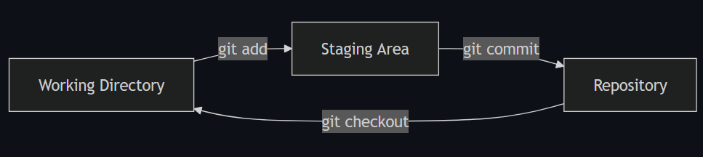
Working directory – your project files where you are making changes
Staging area – a preparation area for grouping changes you want to save to history
Repository – the permanent records of your project’s development history

Some important git commands
git init - Start a new repository to enable versioning.
git add - Group related changes together in the staging area, in preparation to "commit" them to history.
git commit - Save or "commit" the changes in the staging area to the project's history.
- commit message - A short description of the changes to help keep the history organized.
git status - View the current state of your working directory and staging area.
git checkout - Change your working directory to a different version from the repository history.

Glossary
Working tree: The set of nested directories and files that contain the project that's being worked on.
Repository (repo): The data store, contained in a hidden directory named .git at the top level of a working tree, where Git keeps all the history and metadata for a project. Repositories are almost always referred to as repos. A bare repository is one that isn't part of a working tree; it's used for sharing or backup. A bare repo is usually a directory with a name that ends in .git—for example, project.git.
Hash: A number produced by a hash function that represents the contents of a file or another object as a fixed number of digits. Git traditionally uses SHA-1 hashes that are 160 bits long, though modern versions of Git also support SHA-256 (256 bits). One advantage to using hashes is that Git can tell whether a file has changed by hashing its contents and comparing the result to the previous hash. If the file time-and-date stamp is changed, but the file hash isn’t changed, Git knows the file contents aren’t changed.
Object: A Git repo contains four types of objects, each uniquely identified by a hash. A blob object contains an ordinary file. A tree object represents a directory; it contains names, hashes, and permissions. A commit object represents a specific version of the working tree. An annotated tag object stores metadata, such as a name, message, and optional signature, and usually points to a commit, though it can point to other Git objects as well. Git also supports lightweight tags, which are references rather than objects.
Commit: When used as a verb, commit means to make a commit object. This action takes its name from commits to a database. It means you are committing the changes you have made so that others can eventually see them, too.
Branch: A branch is a named series of linked commits. The most recent commit on a branch is called the head. The default branch, which is created when you initialize a repository, is called main on GitHub and many other platforms. The head of the current branch is named HEAD. Branches are an incredibly useful feature of Git because they allow developers to work independently (or together) in branches and later merge their changes into the default branch.
Remote: A remote is a named reference to another Git repository. When you clone a repo, Git creates a remote named origin that points to the repository you cloned from. origin is the default remote for push and pull operations.
Commands, subcommands, and options: Git operations are performed by using commands like git push and git pull. git is the command, and push or pull is the subcommand. The subcommand specifies the operation you want Git to perform. Commands frequently are accompanied by options, which use hyphens (-) or double hyphens (--). For example, git reset --hard.

